Module -17) Php – Introduction of Laravel Php

Framework -Industry

1)What Is Laravel?

Ans:

* **Laravel** is a free, open-source PHP framework designed for building web applications with an expressive and elegant syntax. It follows the **Model-View-Controller (MVC).**
* Architectural pattern and simplifies tasks commonly performed in web development, such as routing, authentication, caching, and database operations.

2)Advantages of Laravel?

Ans:

* Creating authorization and authentication system.
* Integration with tools.
* Mail service integration.
* Handing exception and configuration error.
* Automation testing work.
* Separation of business logic code from presentation code .

3)Features of Laravel.

Ans:

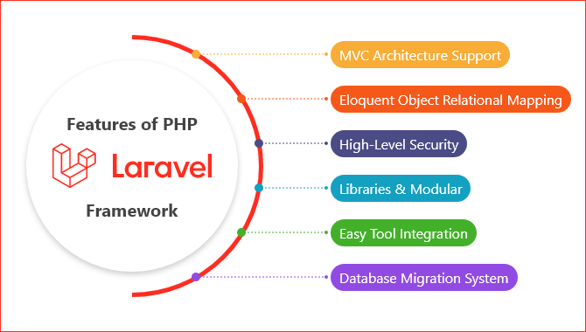

4)Requirement for using Laravel Framework.

Ans:

* PHP – 8.1 version of XAMPP or greater than
* XAMPP is a free, open -source software package that lets you test and develop websites on a local server. It’s a popular PHP development environment that easy to install and use. XAMPP stands for:
* X: cross-platform
* A: Apache server
* M: MariaDB
* P: PHP
* P: Per

Composer: composer is a tool which includes all the dependencies and libraries. It allows a user to create a project with respect to the mentioned framework. Third party libraries can be installed easily with help of composer.

All the dependencies are noted in composer json file which is placed in the source folder.

5) What is Framework?

Ans:

A **framework** in software development is a pre-built, structured collection of tools, libraries, and best practices that help developers build applications more efficiently and effectively. It provides a foundation that allows developers to focus on writing the application-specific logic, without having to repeatedly handle low-level details or reinvent common features.

6) What is MVC ?

Ans:

The Model-View-controller (MVC) framework is an architecture

Design pattern that separates an application into three main logical components Model, view, and Controller.

Each architectural component is built to handle specific development aspects of an application. It isolates the business logic and presentation layer from each other.

7)Features of MVC?

Ans:

Here are the **easy-to-understand features** of the **MVC (Model-View-Controller)** pattern:

1. **Separation of Parts**: It divides an app into three parts:
   * **Model** (handles data),
   * **View** (displays the UI),
   * **Controller** (processes user actions). This keeps the code organized.
2. **Reusability**: You can reuse parts of the code, like using the same Model with different Views (e.g., desktop and mobile).
3. **Easy to Maintain**: Since everything is separated, it's easier to find and fix problems or update parts without breaking the whole app.
4. **Faster Development**: Teams can work on different parts (Model, View, or Controller) at the same time, speeding up the development process.
5. **Multiple Views**: You can have different ways of showing the same data (e.g., list view and grid view) without changing the core logic.
6. **Easier Testing**: You can test each part (Model, View, Controller) separately, making sure everything works correctly.
7. **Scalability**: The clear structure makes it easier to grow the application as more features are added.

In short, MVC keeps things organized, helps developers work faster, and makes it easier to maintain and expand applications.